Final Project Report

<<PROJECT NAME>>



Project Supervisor
<<Project Supervisor Name>>

Submitted By

<<Project Group ID>>

<<Group Member Name>> <<VU ID>>
<<Group Member Name>> <<VU ID>>

Software Projects & Research Section,
Department of Computer Sciences,
Virtual University of Pakistan


CERTIFICATE

This is to certify that <<First Member Name>> (<<VU ID>>), <<Second Member Name>> (<<VU ID>>) have worked on and completed their Software Project at Software & Research Projects Section, Department of Computer Sciences, Virtual University of Pakistan in partial fulfillment of the requirement for the degree of BS in Computer Sciences under my guidance and supervision.

In our opinion, it is satisfactory and up to the mark and therefore fulfills the requirements of BS in Computer Sciences.

Supervisor / Internal Examiner

<<Project Supervisor Name>>
Supervisor,
Software Projects & Research Section,
Department of Computer Sciences
Virtual University of Pakistan

___________________
(Signature)

External Examiner/Subject Specialist
<<External Supervisor Name>>

___________________
(Signature)

Accepted By:

_____________
(For office use)

EXORDIUM

In the name of Allah, the Compassionate, the Merciful.

Praise be to Allah, Lord of Creation,
The Compassionate, the Merciful,
King of Judgment-day!

You alone we worship, and to You alone we pray for help,
Guide us to the straight path

The path of those who You have favored,

Not of those who have incurred Your wrath,
Nor of those who have gone astray.

DEDICATION

ACKNOWLEDGEMENT
PREFACE
TABLE OF CONTENTS

CHAPTER NO. 1
gathering & Analyzing info 10

1.1 Introduction

1.2 purpose

1.3 scope

1.4 definitions, acronyms and abbreviations

1.5 Project requirements

1.5.1 Functional Requirements

1.5.2 Non-Functional Requirements

1.6 use cases and usage scenarios

1.6.1 Use Case Diagrams

1.6.2 Usage Scenarios

1.7 Development Methodology

1.7.1 Chosen Methodology

1.7.2 Reasons for Chosen Methodology
1.7.2 Work Plan (Gantt Chart)
1.7.2 Project Schedule (Submission Calendar)

CHAPTER NO. 2
designing the project 12

2.1 Introduction

2.2 purpose

2.3 scope

2.4 definitions, acronyms and abbreviations

2.5 Architectural Representation (Architecture Diagram)

2.6 Dynamic Model: Sequence Diagrams

2.7 Object Model/Logical Model: Class Diagram

2.8 Database Model (Database Diagram)

2.9 Graphical User Interfaces

Chapter no.3
DEvelopment 13
3.1 Development plan (Architecture Diagram)

<<Dear Students, you have to take special care of page numbers, which are written against each Chapter and sub headings. You have to mention your own page numbers and correct one against each document heading. Make proper table of contents. Remember that if there are any new headings or you have included more headings in your documents then you also have to write these in table of contents and modify table of contents according to your documents material>>

<<Dear Students, before starting each chapter the following would be the title page for each chapter on a separate page>>

CHAPTER 1
Gathering & Analyzing Info

1.1Introduction

Airport Management System
The airport management system is a comprehensive desktop application designed to facilitate and optimize the daily operations of an airport. This system encompasses various functionalities crucial for efficient airport management, including flight scheduling, passenger processing, ticketing, airline management, baggage handling, and more. The system integrates multiple modules to ensure seamless communication and data flow between different departments, providing a unified platform to manage airport operations effectively. The application will be developed using C# with Windows Presentation Foundation (WPF) for the user interface, and SQL for the database management.

1.2 PURPOSE
The primary purpose of the airport management system is to automate and streamline various processes involved in airport management. This includes:
- Flight Management: Scheduling, tracking, and updating flight information.
- Passenger Management: Handling passenger data, check-ins, and boarding procedures.
- Ticketing: Managing ticket sales, reservations, and cancellations.
- Airline Coordination: Facilitating communication and coordination with different airlines.
- Baggage Handling: Tracking and managing passenger baggage to ensure efficient handling and minimize lost baggage incidents.
- Operational Efficiency: Enhancing the overall operational efficiency of the airport by integrating different processes into a single system.

1.3 SCOPE
The system is designed to cover a wide range of functionalities required for efficient airport management, including but not limited to flight scheduling, passenger processing, ticket management, and baggage handling.

1.4 DEFINITIONS, ACRONYMS AND ABBREVIATIONS
- AMS: Airport Management System
- WPF: Windows Presentation Foundation
- CRUD: Create, Read, Update, Delete

1.5 PROJECT REQUIREMENTS

1.5.1 Functional Requirements
- Flight Management
- Passenger Management
- Ticketing
- Airline Coordination
- Baggage Handling

1.5.2 Non-Functional Requirements
- Performance Optimization
- Scalability
- Maintainability
- Security
- Data Integrity

1.6 USE CASES AND USAGE SCENARIOS

1.6.1 Use Case Diagrams

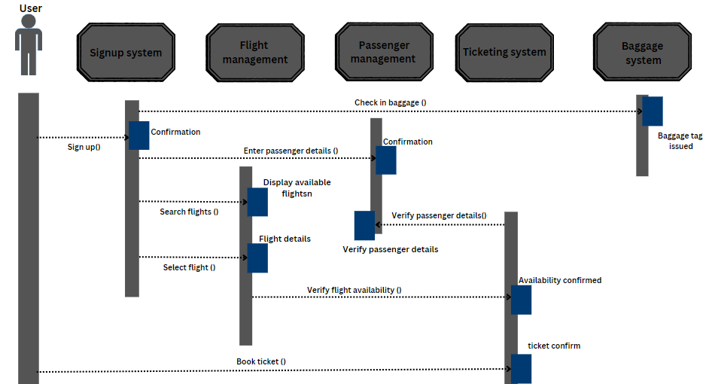

1.6.2 Usage Scenarios
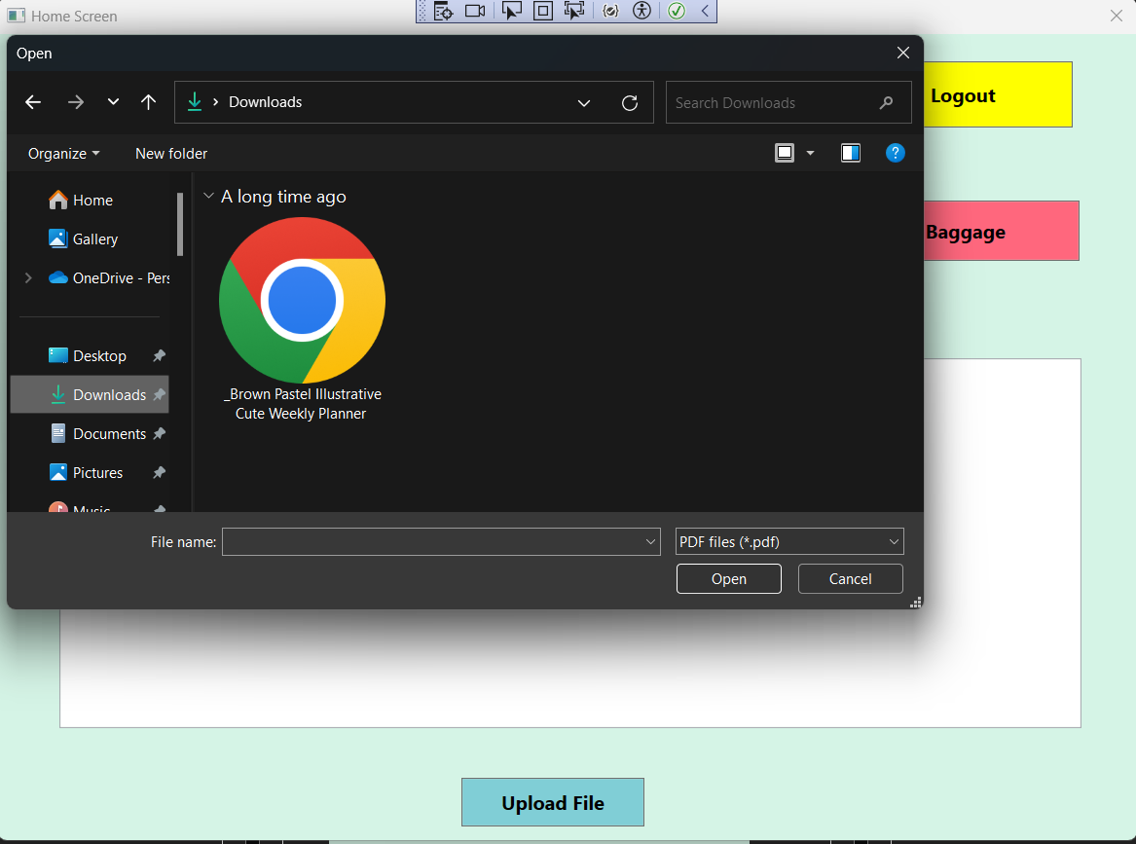
By clicking the upload button we can upload the document in the application. We can upload .txt, .pdf and .doc file in the application
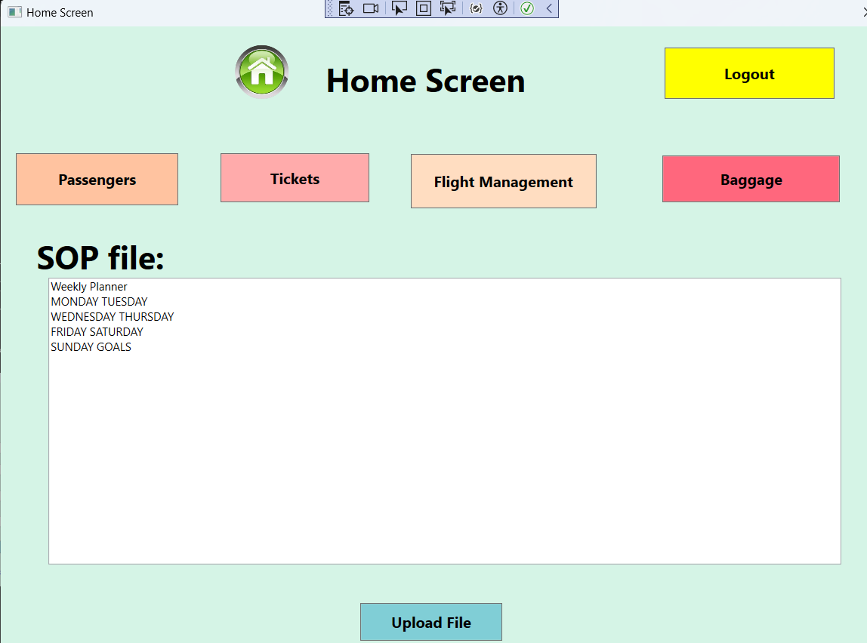
By selecting the file and opening it in the application the content of the file is displayed in the text field

1.7 DEVELOPMENT METHODOLOGY

1.7.1 Chosen Methodology
The development of the airport management system will be carried out using the following technologies:
- C# with WPF (Windows Presentation Foundation): This will be used for developing the desktop application's user interface. WPF provides a rich UI framework that supports the creation of sophisticated and interactive interfaces.
- SQL: This will be used for database management. SQL databases are robust and reliable, providing a solid foundation for managing the complex data requirements of the airport management system.

1.7.2 Reasons for Chosen Methodology
- C# with WPF (Windows Presentation Foundation):
  - Rich UI Framework: WPF provides advanced features for creating sophisticated and interactive user interfaces, which is essential for an application that requires a high level of user interaction and visual appeal.
  - Integration: WPF seamlessly integrates with other Microsoft technologies and tools, ensuring smooth development and deployment processes.
  - Performance: WPF offers better performance for desktop applications, especially those with complex UI elements, due to its hardware acceleration capabilities.
- SQL:
  - Reliability: SQL databases are known for their robustness and reliability, making them suitable for managing critical and complex data requirements of an airport management system.
  - Scalability: SQL databases can efficiently handle increasing amounts of data and users, which is crucial for an expanding airport.
  - Data Integrity: SQL provides strong data integrity and consistency through features like ACID (Atomicity, Consistency, Isolation, Durability) compliance, ensuring reliable data management.
  - Query Efficiency: SQL allows for efficient querying and manipulation of data, which is necessary for the real-time data requirements of the airport management system.

1.7.3 Work Plan (Gantt Chart)

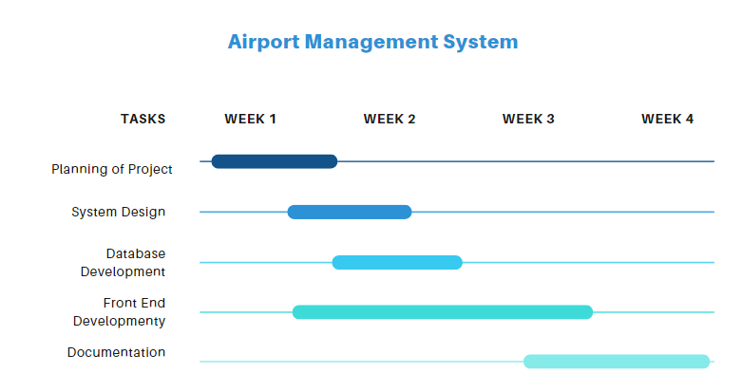1.7.4 Project Schedule (Submission Calendar)
[Include the submission calendar here]

CHAPTER 2
Designing the Project

2.1 INTRODUCTION
This chapter covers the design aspects of the Airport Management System, including architectural representation, dynamic modeling, object modeling, database design, and graphical user interfaces.

2.2 PURPOSE
The purpose of this chapter is to present the design framework that will guide the development and implementation of the Airport Management System.

2.3 SCOPE
This chapter outlines the architectural, dynamic, object, and database models as well as the user interface design for the system.

2.4 DEFINITIONS, ACRONYMS AND ABBREVIATIONS
- ERD: Entity-Relationship Diagram
The provided Entity-Relationship Diagram (ERD) illustrates the structure and relationships among different entities in the airport management system.

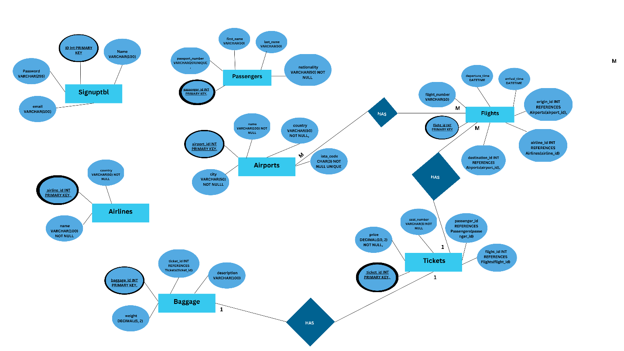

Relationships:
- Flights to Airports
  - origin_id references airport_id (One-to-Many)
  - destination_id references airport_id (One-to-Many)
- Flights to Airlines
  - airline_id references airline_id (One-to-Many)
- Tickets to Flights
  - flight_id references flight_id (One-to-Many)
- Tickets to Passengers
  - passenger_id references passenger_id (One-to-Many)
- Baggage to Tickets
  - ticket_id references ticket_id (One-to-Many)

2.5 ARCHITECTURAL REPRESENTATION (ARCHITECTURE DIAGRAM)

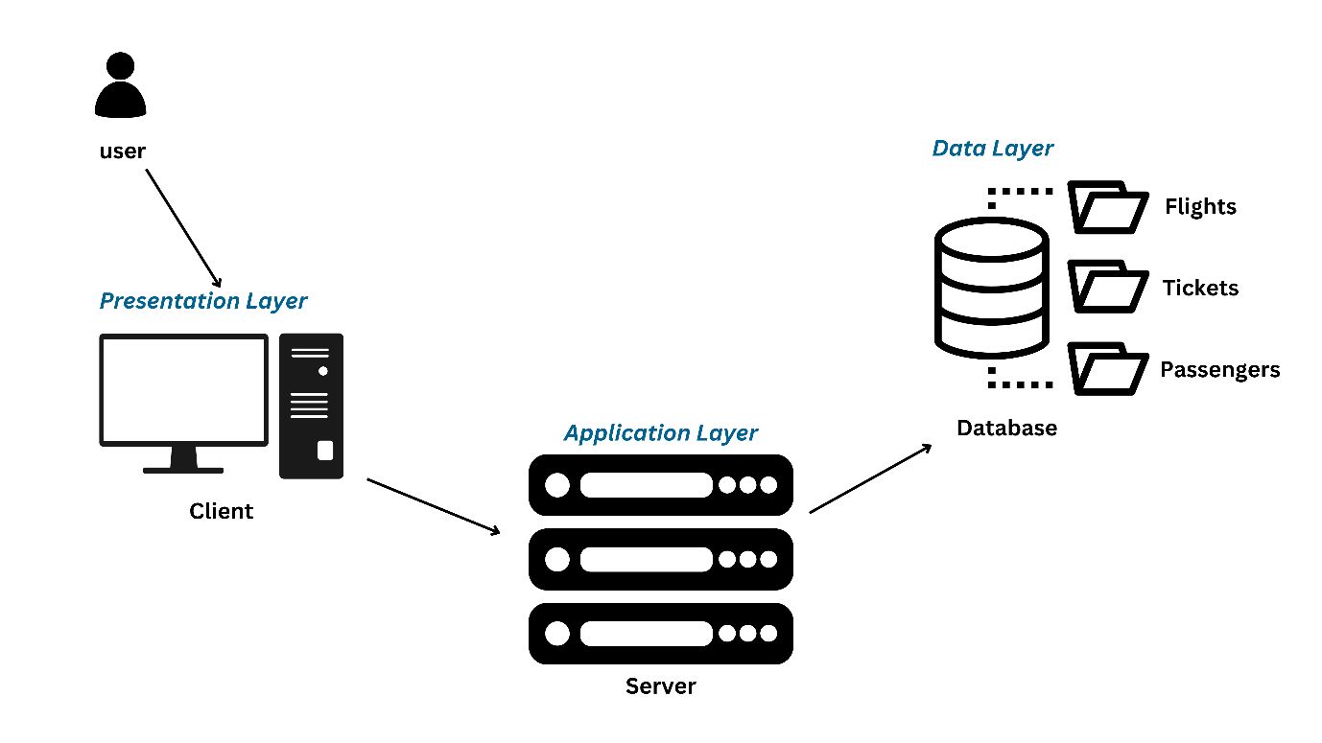

The architecture of the Airport Management System can be divided into three main layers: Presentation Layer, Application Layer, and Data Layer. This design ensures modularity, scalability, and maintainability.

1. Presentation Layer
- Components: Client (User Interface)
- Description:
  - The Presentation Layer is the front-end interface through which users interact with the system. It includes a computer or any device that runs the client application.
  - Users can perform various actions such as searching for flights, booking tickets, checking passenger details, and managing baggage.
  - The client application collects user input and displays the results returned from the Application Layer.

2. Application Layer
- Components: Server
- Description:
  - The Application Layer serves as the intermediary between the Presentation Layer and the Data Layer. It processes the business logic of the application.
  - The server receives requests from the client, processes them, and then interacts with the database to retrieve or update data.
  - This layer ensures that the correct data is fetched from the database, processed according to the business rules, and then sent back to the client in a user-friendly format.

3. Data Layer
- Components: Database
- Description:
  - The Data Layer consists of a database that stores all the data related to the airport management system, including flights, tickets, and passengers.
  - It maintains the integrity, security, and availability of the data.
  - The database can be accessed by the Application Layer to perform CRUD (Create, Read, Update, Delete) operations.

Data Flow
- User Interaction:
  - Users interact with the client application to perform various actions such as searching for flights, booking tickets, and managing baggage.
- Request Handling:
  - The client application sends the user requests to the server in the Application Layer.
- Processing:
  - The server processes the requests, applies the business logic, and interacts with the database as needed.
- Database Operations:
  - The server queries the database to retrieve or update the necessary information.
- Response:
  - The server sends the processed data back to the client application.
- User Display:
  - The client application displays the data to the user in a readable format.

2.6 DYNAMIC MODEL: SEQUENCE DIAGRAMS
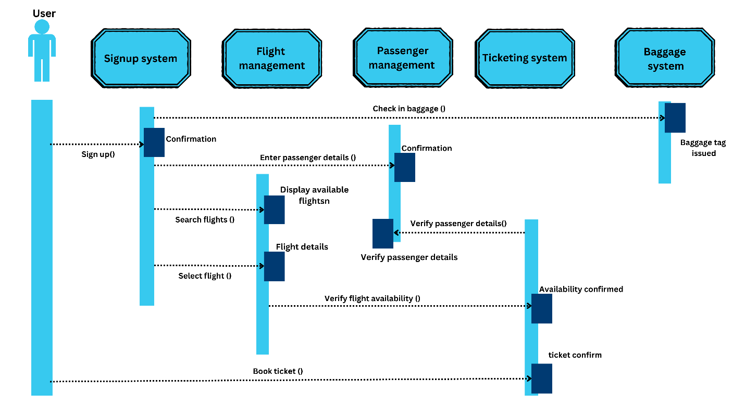
The sequence diagram provides a detailed representation of the interactions between the user and various subsystems within the airport management application. The main subsystems involved are the Signup System, Flight Management System, Passenger Management System, Ticketing System, and Baggage System.

User Interaction with Signup System:
  - The user initiates the process by signing up through the Signup System.
  - The Signup System processes the signup request and sends a confirmation back to the user.

Flight Search and Selection:
  - The user searches for available flights through the Flight Management System.
  - The Flight Management System retrieves and displays the available flight options to the user.
  - The user selects a desired flight from the displayed options.

Passenger Details Entry:
  - Once a flight is selected, the user enters passenger details into the system.
  - The Passenger Management System verifies the passenger details and sends a confirmation back to the user.

Flight Verification and Ticket Booking:
  - The Flight Management System verifies the availability of the selected flight.
  - Upon confirmation of availability, the user proceeds to book the ticket.
  - The Ticketing System verifies the flight details and confirms the ticket booking.

Baggage Check-in:
  - The user checks in baggage through the Baggage System.
  - The Baggage System verifies the ticket and passenger details, then issues a baggage tag confirming the check-in.
Throughout this sequence, the user interacts with multiple subsystems to complete the process of signing up, searching for flights, entering passenger details, booking tickets, and checking in baggage, with each subsystem verifying and confirming the details at each step. This sequence ensures a smooth and systematic flow of operations within the airport management system, enhancing the user experience and ensuring data integrity.

2.7 OBJECT MODEL/LOGICAL MODEL: CLASS DIAGRAM
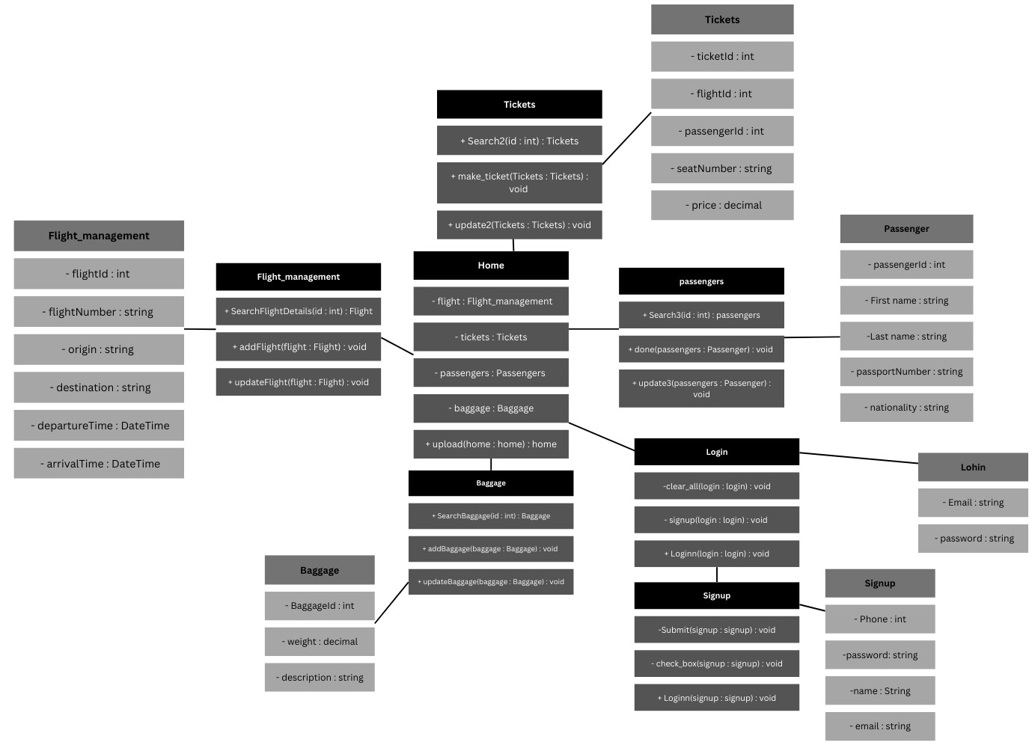

This class diagram represents the structure and relationships between various classes in the Airport Management System. The system is divided into several key classes that manage different aspects of airport operations, including flights, tickets, passengers, and baggage.

1. Tickets Class
- Attributes:
  - ticketid : int - Unique identifier for the ticket.
  - flightid : int - Identifier for the associated flight.
  - passengerid : int - Identifier for the associated passenger.
  - seatNumber : string - Seat number assigned to the ticket.
  - price : decimal - Price of the ticket.
- Methods:
  - Search2(id : int) : Tickets - Searches for a ticket by its ID.
  - make_ticket(Tickets : Tickets) : void - Creates a new ticket.
  - update2(Tickets : Tickets) : void - Updates an existing ticket.

2. Flight_management Class
- Attributes:
  - flightid : int - Unique identifier for the flight.
  - flightNumber : string - Flight number.
  - origin : string - Origin of the flight.
  - destination : string - Destination of the flight.
  - departureTime : DateTime - Departure time of the flight.
  - arrivalTime : DateTime - Arrival time of the flight.
- Methods:
  - SearchFlightDetails(id : int) : Flight - Searches for flight details by its ID.
  - addFlight(flight : Flight) : void - Adds a new flight.
  - updateFlight(flight : Flight) : void - Updates an existing flight.

3. Home Class
- Attributes:
  - flight : Flight_management - Reference to the flight management.
  - tickets : Tickets - Reference to the tickets.
  - passengers : Passengers - Reference to the passengers.
  - baggage : Baggage - Reference to the baggage management.

4. Passengers Class
- Attributes:
  - passengerid : int - Unique identifier for the passenger.
  - First name : string - First name of the passenger.
  - Last name : string - Last name of the passenger.
  - passportNumber : string - Passport number of the passenger.
  - nationality : string - Nationality of the passenger.
- Methods:
  - Search2(id : int) : passengers - Searches for a passenger by their ID.
  - done1(passengers : Passenger) : void - Adds a new passenger.
  - update3(passengers : Passenger) : void - Updates an existing passenger.

5. Baggage Class
- Attributes:
  - Baggageid : int - Unique identifier for the baggage.
  - weight : decimal - Weight of the baggage.
  - description : string - Description of the baggage.
- Methods:
  - Searchbaggaeid(id : int) : Baggage - Searches for baggage by its ID.
  - addbaggage(baggage : Baggage) : void - Adds a new baggage.
  - updatebaggage(baggage : Baggage) : void - Updates an existing baggage.

Relationships
- Aggregation (Unfilled Diamond):
  - Home aggregates Flight_management, Tickets, Passengers, and Baggage.
  - This signifies that the Home class contains references to instances of these other classes, indicating a "whole-part" relationship without implying ownership.

2.8 DATABASE MODEL (DATABASE DIAGRAM)
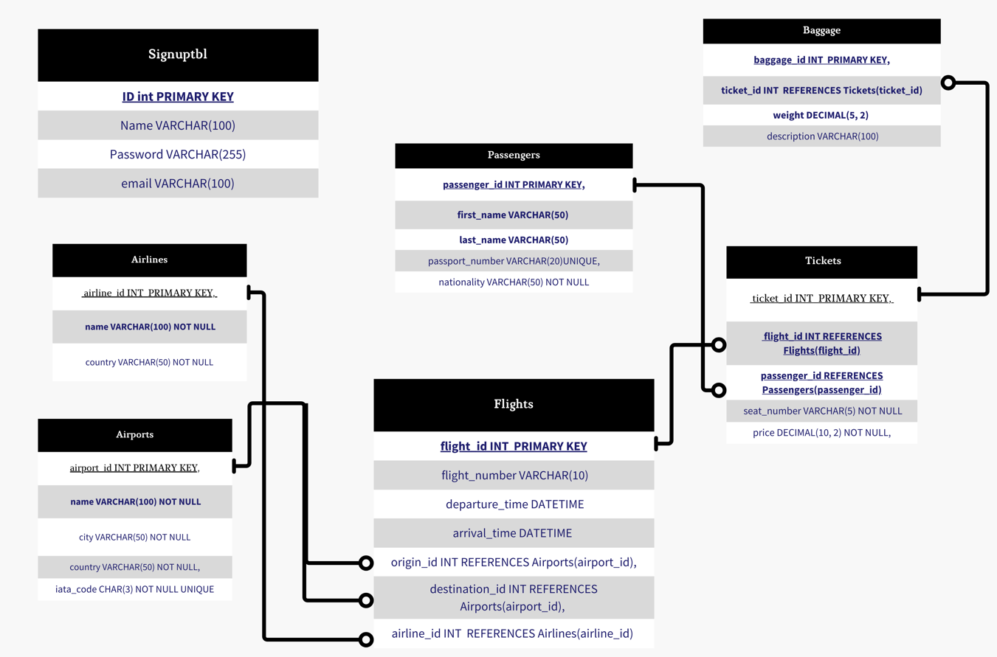

The provided Entity-Relationship Diagram (ERD) illustrates the database design for an airport management system. The database comprises several interconnected tables, each representing a fundamental component of the system.
- Signup Table: This table captures user registration details, including a unique identifier (ID), name, email, and password. It serves as the entry point for user authentication and authorization within the system.
- Airlines Table: This table stores information about airlines, including a unique airline identifier (airline_id), name, and country of origin. It helps in managing airline-specific data and associating flights with respective airlines.
- Airports Table: This table holds details about airports, with each airport identified by a unique airport_id. It includes the airport's name, city, country, and a unique IATA code. The table is crucial for defining the origin and destination points for flights.
- Flights Table: This table records flight details, such as a unique flight identifier (flight_id), flight number, departure and arrival times, origin and destination airport IDs, and the associated airline ID. It establishes foreign key relationships with the Airports and Airlines tables to ensure referential integrity.
- Passengers Table: This table keeps track of passenger information, including a unique passenger identifier (passenger_id), first and last names, passport number, and nationality. It ensures that passenger data is linked correctly with tickets and flights.
- Tickets Table: This table contains ticket details, with each ticket identified by a unique ticket_id. It includes references to the associated flight and passenger IDs, seat number, and price. The foreign key constraints ensure that tickets are correctly linked to specific flights and passengers.
- Baggage Table: This table records baggage details for each ticket, including a unique baggage identifier (baggage_id), ticket ID reference, weight, and description. It ensures that baggage information is tied accurately to the respective ticket.

2.9 GRAPHICAL USER INTERFACES
The interface design of the Airport Management System (AMS) app focuses on intuitive navigation and comprehensive functionality tailored to the needs of airport staff and administrators. Featuring a clean and modern aesthetic, the app's home screen provides quick access to key modules such as flight scheduling, passenger information, baggage tracking, and staff management. Each module is designed with user-friendly controls, ensuring that operators can efficiently perform tasks like updating flight statuses, managing passenger check-ins, and monitoring baggage handling in real-time. The interface prioritizes clarity with informative dashboards and interactive maps to enhance situational awareness and operational efficiency throughout the airport environment.

Start Screen
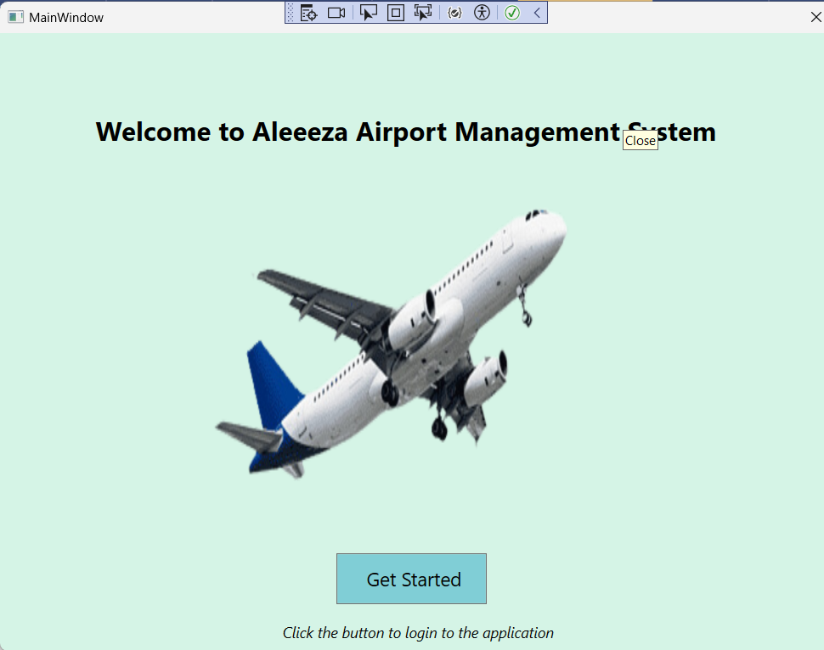

Login Screen
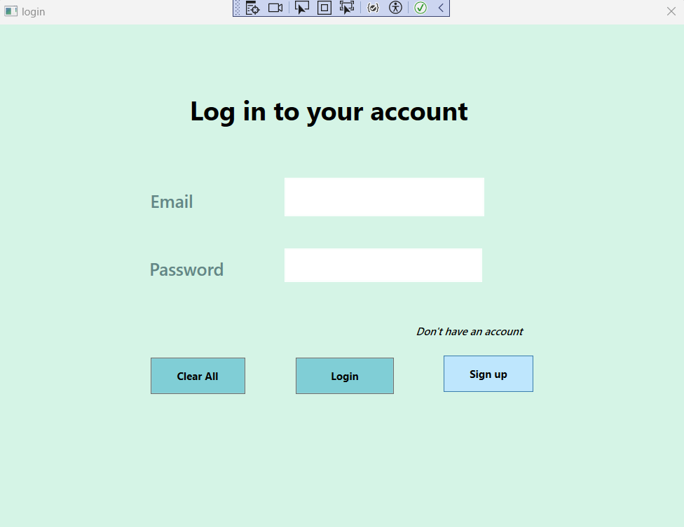

Signup Screen

Terms and Conditions
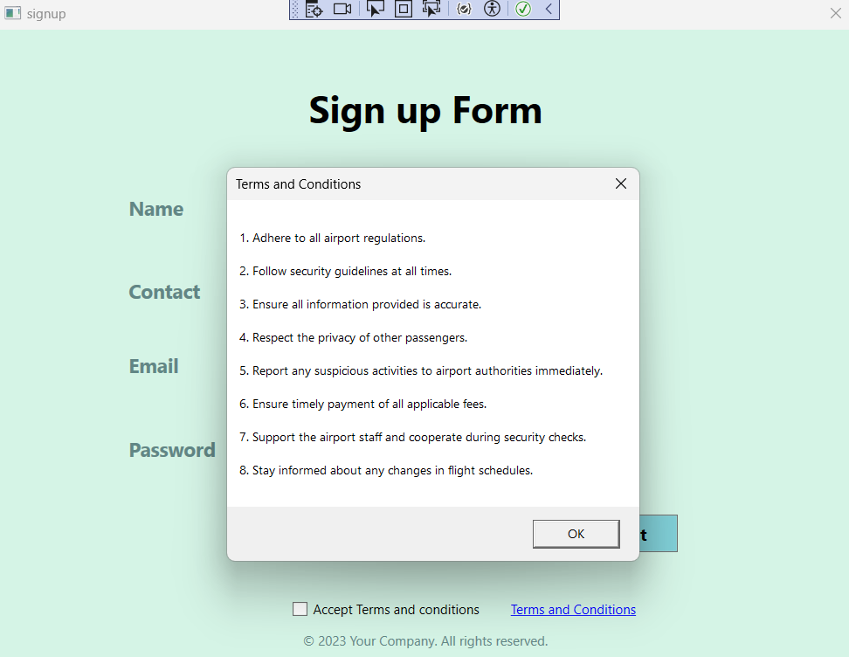

Home Screen

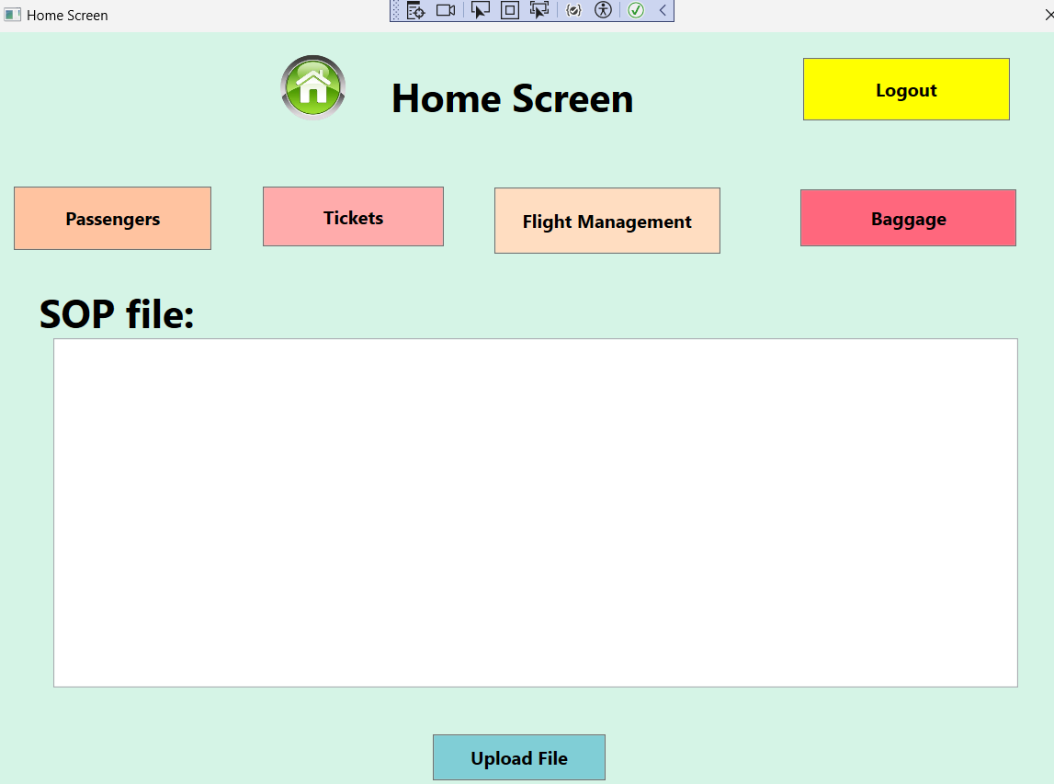

Passengers Management Screen

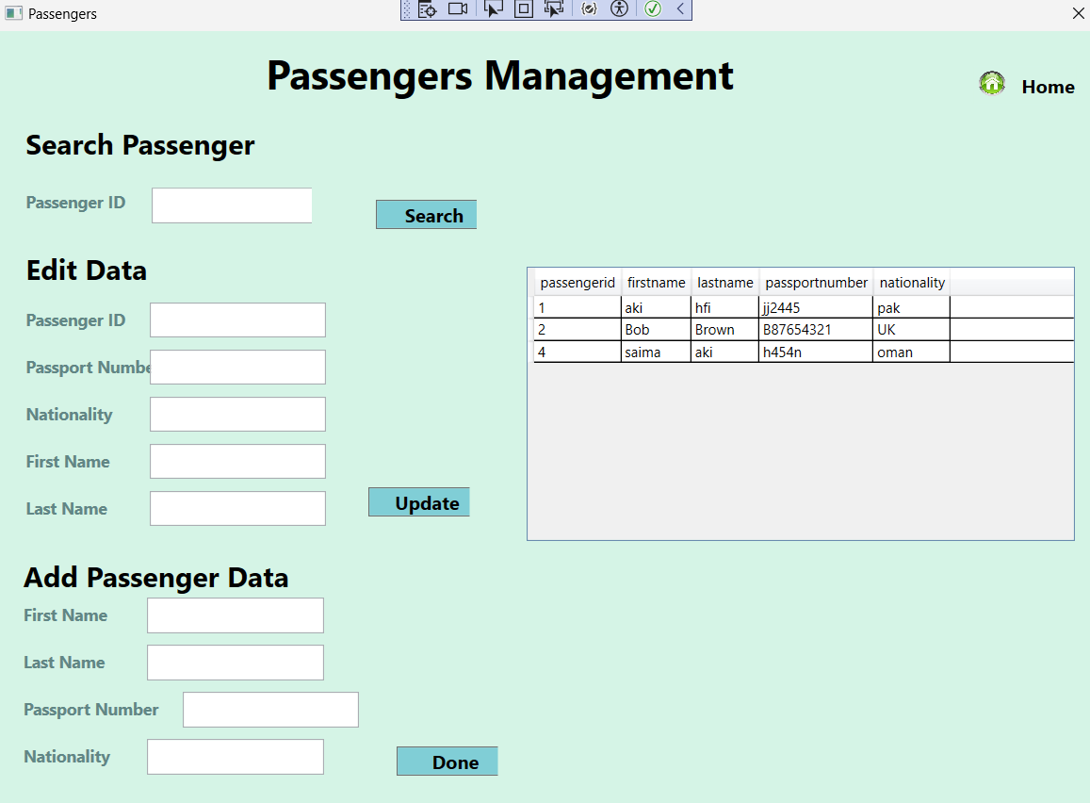

Ticket Management Screen

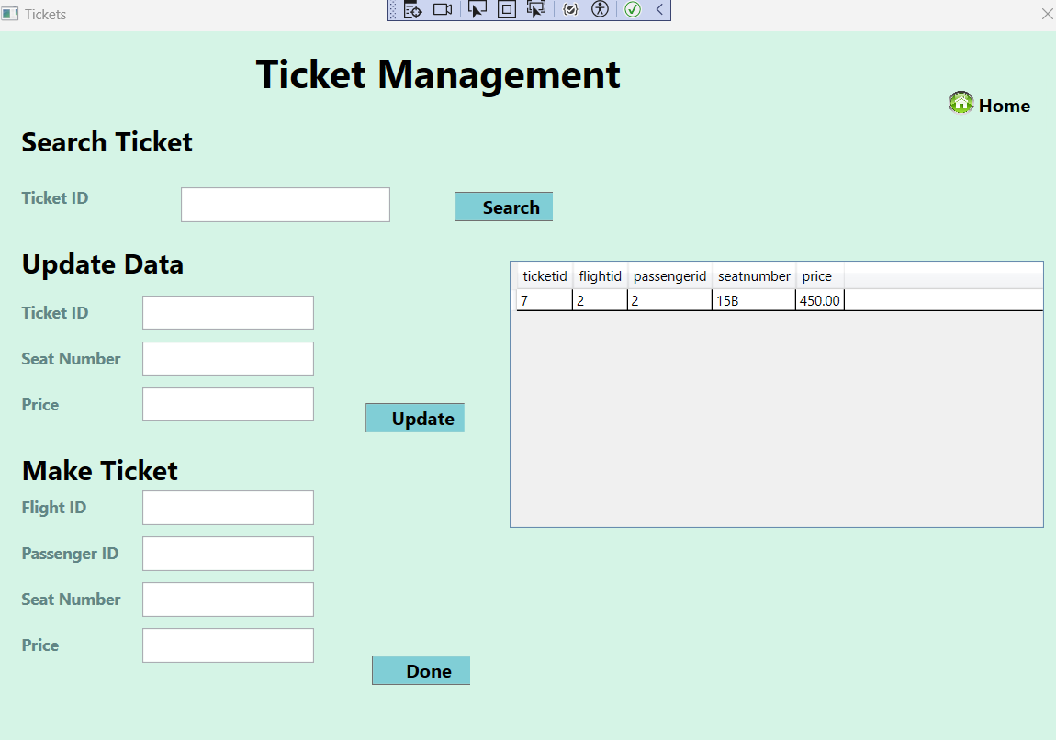

Flight Management Screen

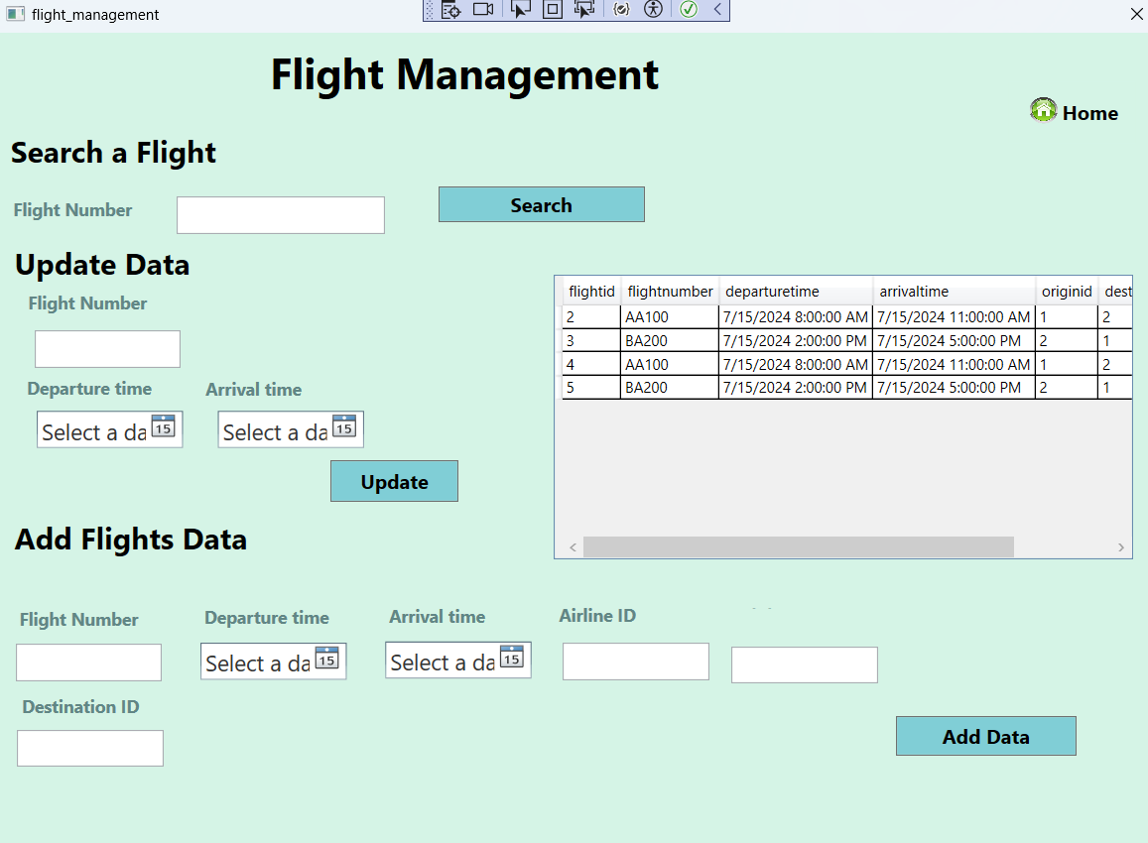

CHAPTER 3
Development

3.1 DEVELOPMENT PLAN (ARCHITECTURE DIAGRAM)

Test Cases

Start Screen
- This shows that by clicking the get started button we come to the login screen.
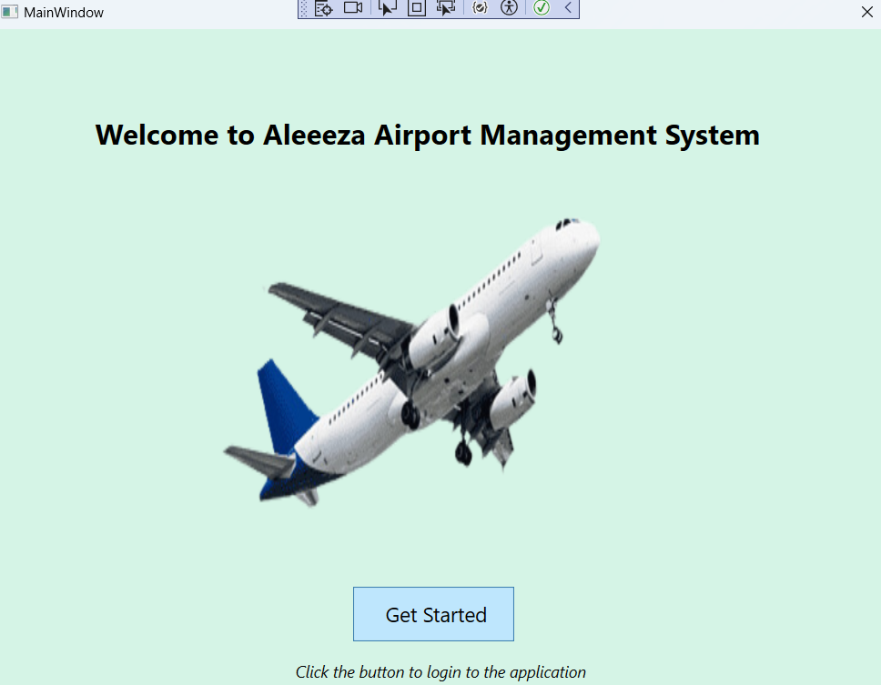

Login Screen
- By clicking the clear all button, all the text is removed from the text boxes.
- On clicking the login button if the credentials are correct, a dialog box will appear to show that the login is successful.
- The signup button will take us to the signup screen.

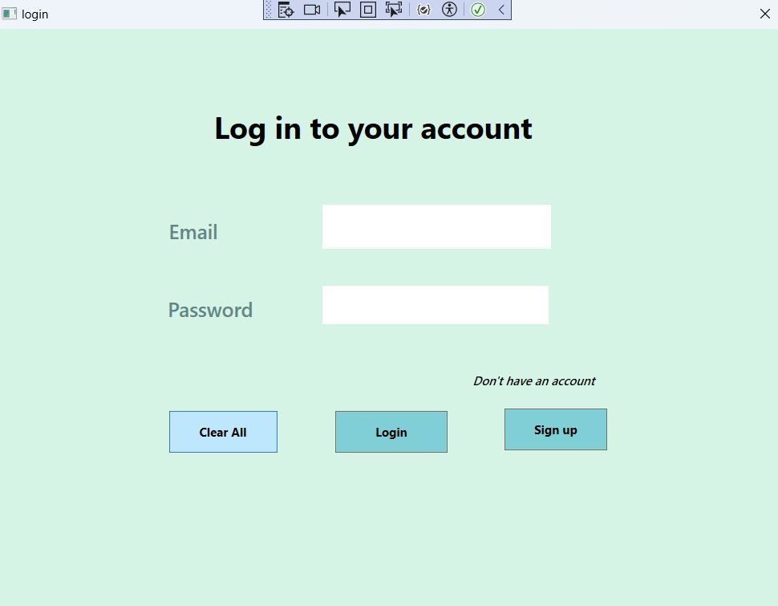
By clicking the clear all button all the text is removed from the text boxes.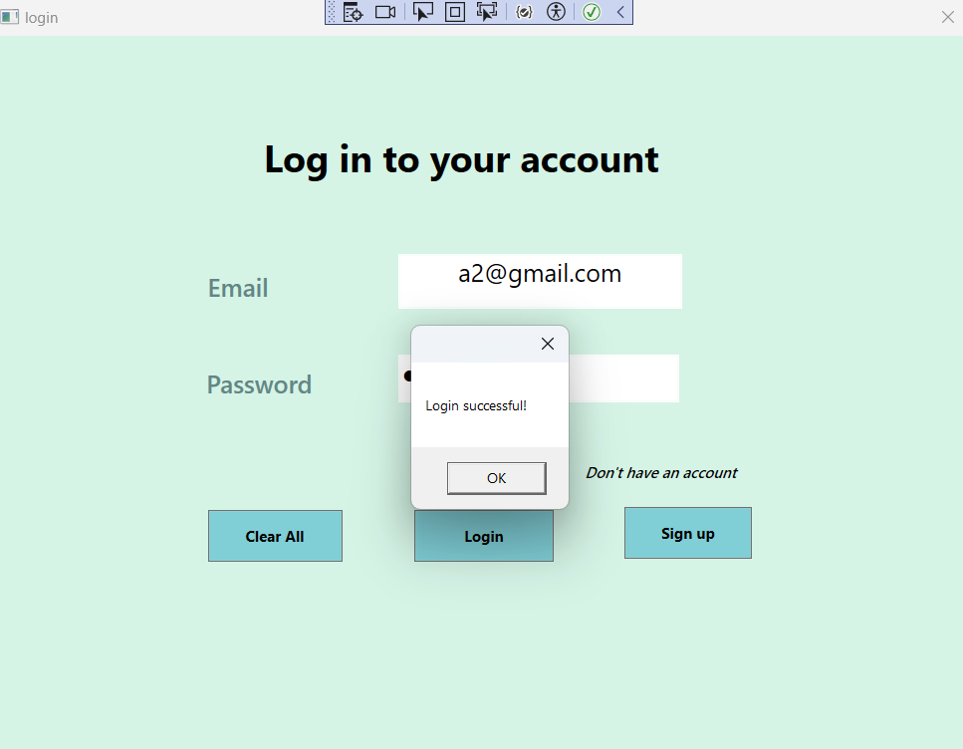
On clicking the login button if the credentials are correct a dialog box will appear to show that the login is successful.
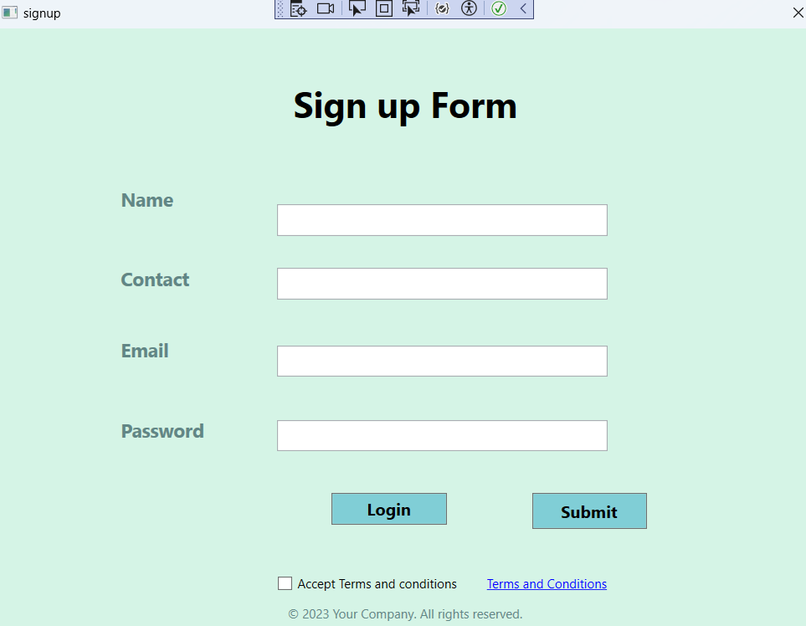
The signup button will take us to the signup screen

Signup Screen
- If we press the submit button without filling out the signup form, a dialog box will appear showing a message to fill the form.
- If we click the submit button and do not check the check box for terms and conditions, a dialog box will appear to show the validation error to check the terms and conditions.

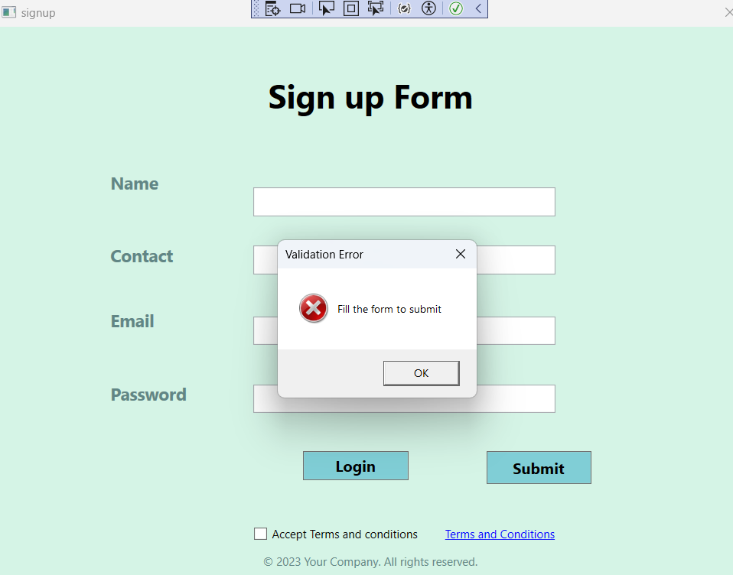
- If we press the submit button without filling out the signup form the dialog box will appear showing a message to fill the form.
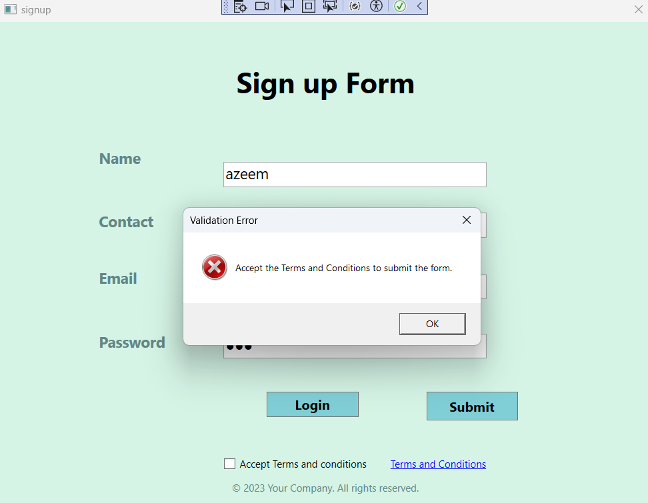
- If we click the submit button and does not check the check box for terms and conditions a dialog box will appear to show the validation error to check the terms and conditions

Home
- By clicking the upload button, we can upload a document in the application. We can upload .txt, .pdf, and .doc files in the application.
- By selecting the file and opening it in the application, the content of the file is displayed in the text field.
- By clicking the upload button we can upload the document in the application. We can upload .txt, .pdf and .doc file in the application
- By selecting the file and opening it in the application the content of the file is displayed in the text field

Flight Management Screen
- We can update the flight time by writing the flight number and selecting the departure and arrival dates from the date picker and clicking the update button. A dialog box will appear to show that the data has been updated.
- By entering the flight number, airline id, origin id, and destination id, and clicking the add data button, a dialog box will appear to show that the data has been added to the database.
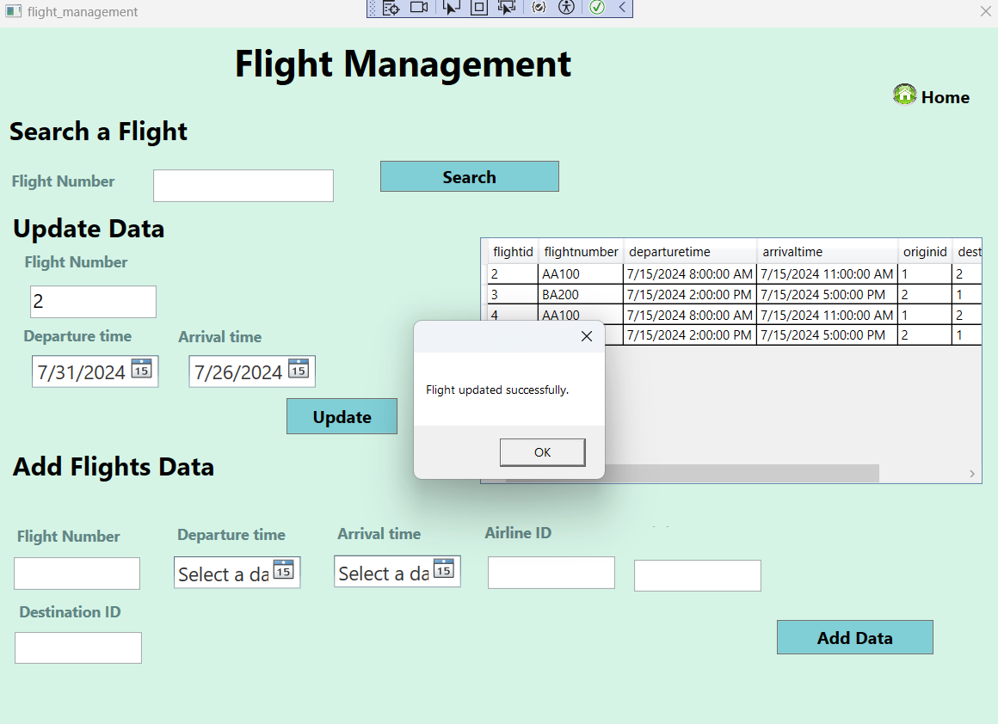
- We can update the flight time by writing the flight number and selecting the departure and the arrival date from the date picker and clicking the update button. The dialog box will appear to show that the data has been update
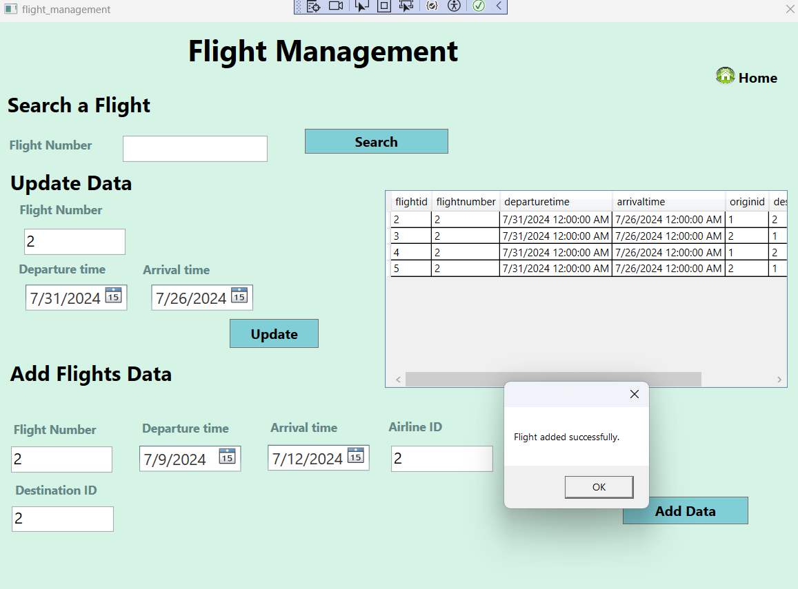
- By entering the flight number, airline id ,origin id and destination id and clicking the add data button the dialog box will appear to show that the data has been added to the database.

Ticket Management Screen
- To make a new ticket record, we can simply add the data and press done. On clicking the done button, we see that the new ticket has been saved in the database. Similarly for the rest of the three screens.
- By entering the ticket id and clicking the search button, we can see the ticket details in the datagrid.
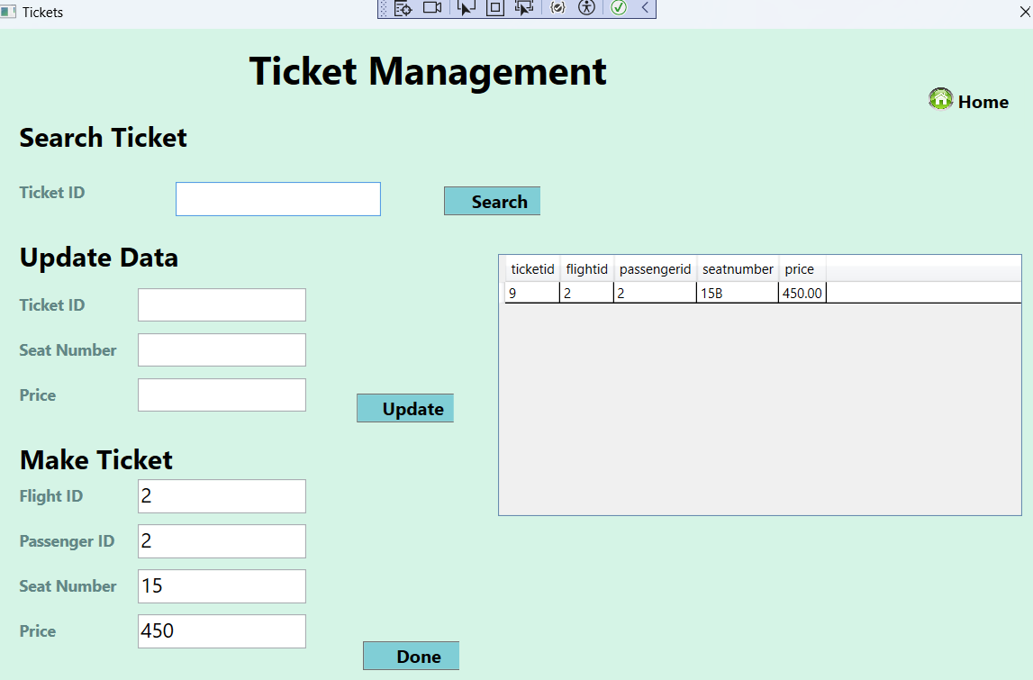
- To make a new ticket record we can simply add the data and press done. On clicking the done button we see that the new ticket has been saved in the database. Similar for the rest of the three screens.

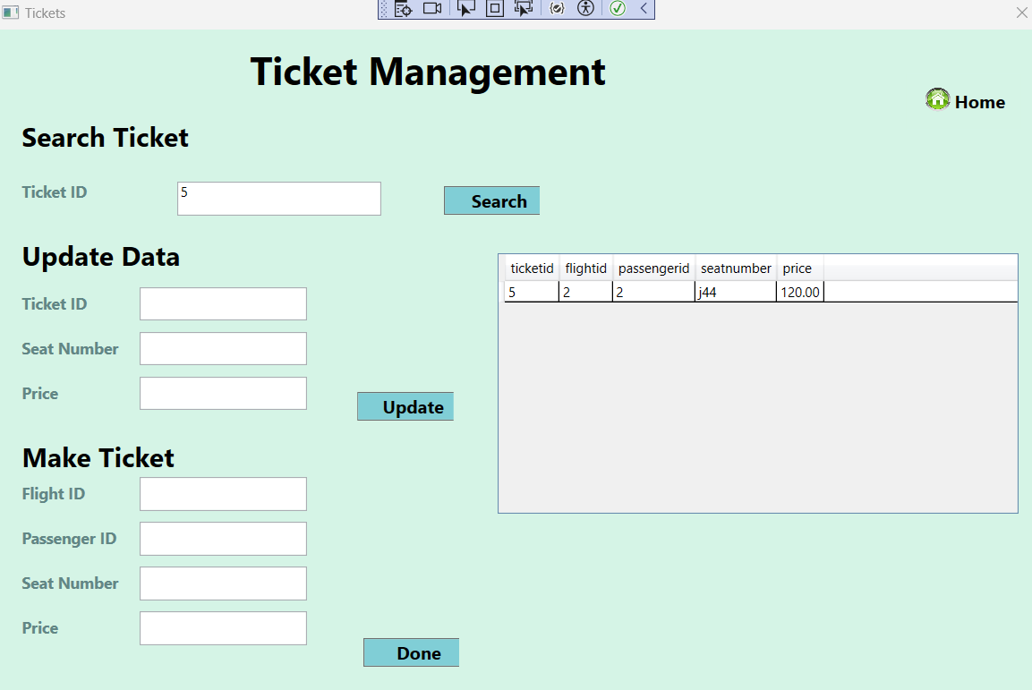

- By entering the ticket id and clicking the search button we can see the ticket details in the datagrid.

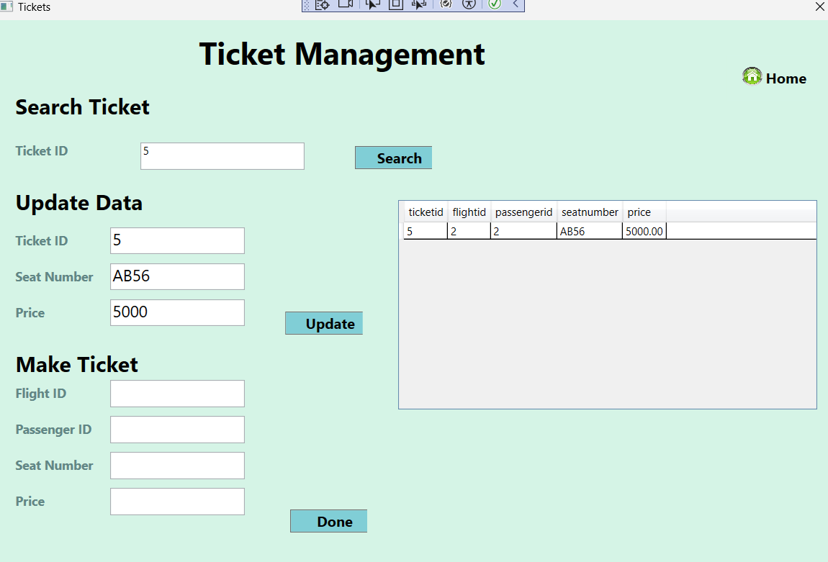
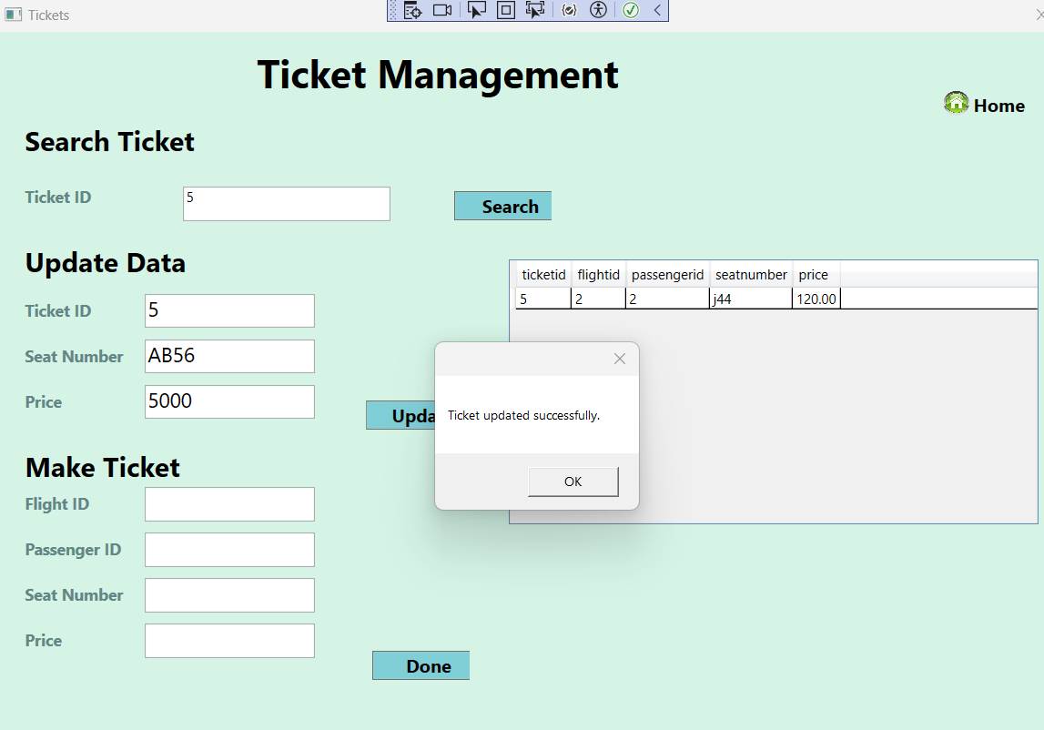

Passenger Management Screen
- We can edit the passenger’s details by adding the data and clicking the update button.
- Similarly, we can add data for a new passenger; this will be shown in the datagrid.
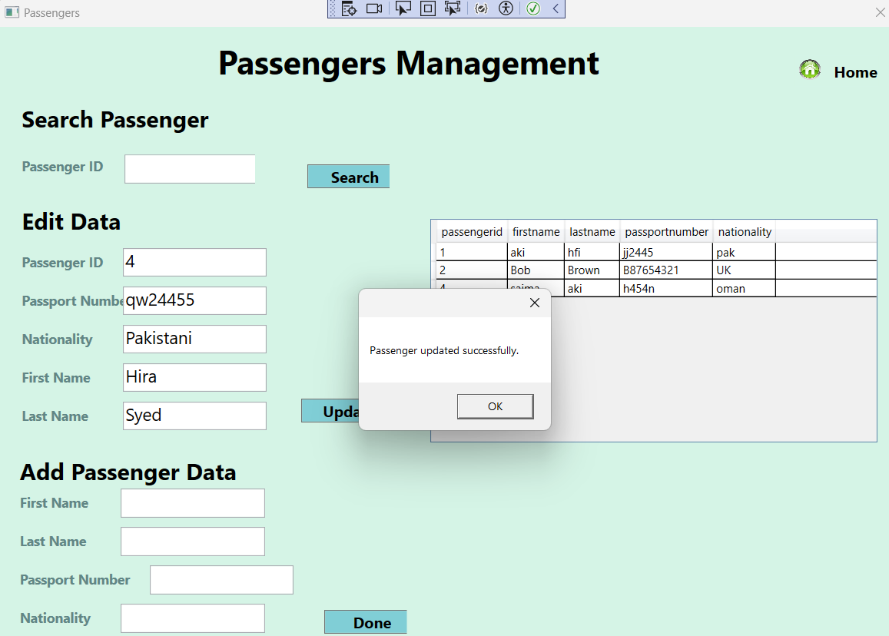
- We can edit the passenger’s details by adding the data and clicking the update button.
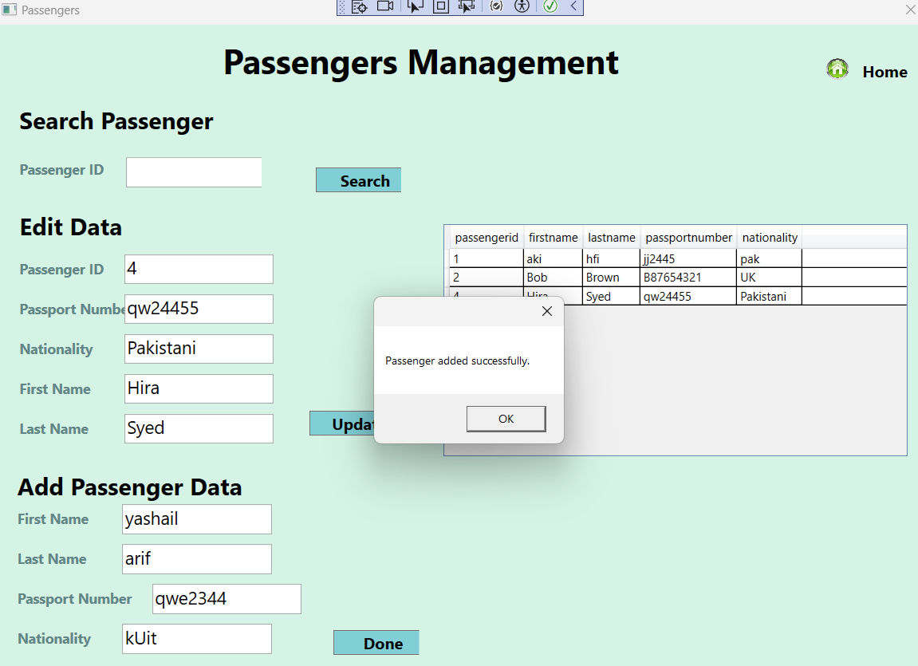
- Similarly we can add data for a new passenger this will be shown in the data grid.
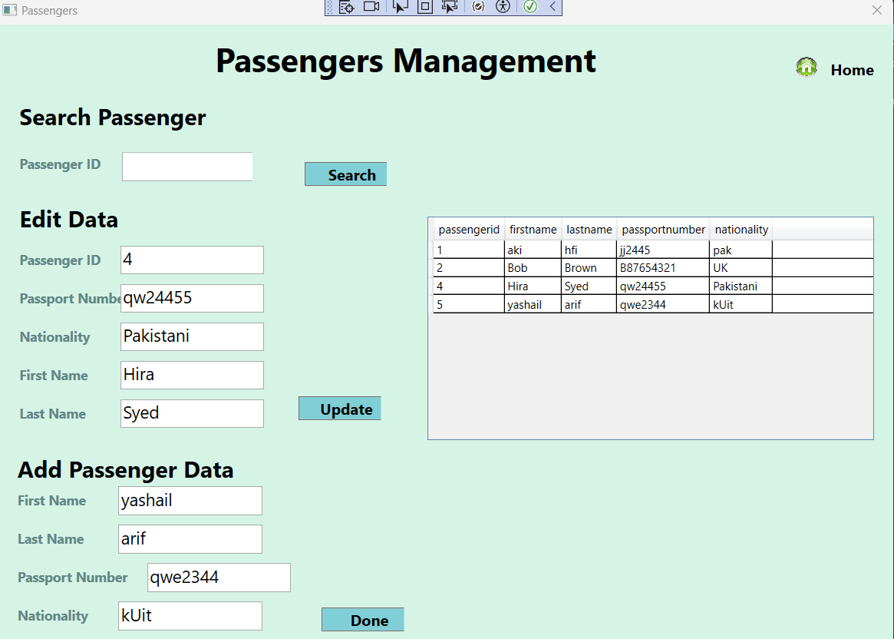
- We can also search for the data of a passenger by entering the passenger id and clicking search button.

Baggage Screen
- We can update the baggage details of a specific ticket by simply adding the details.

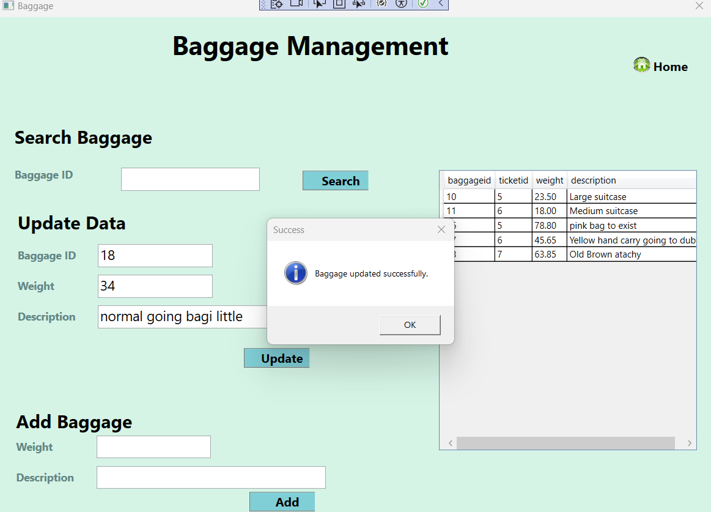

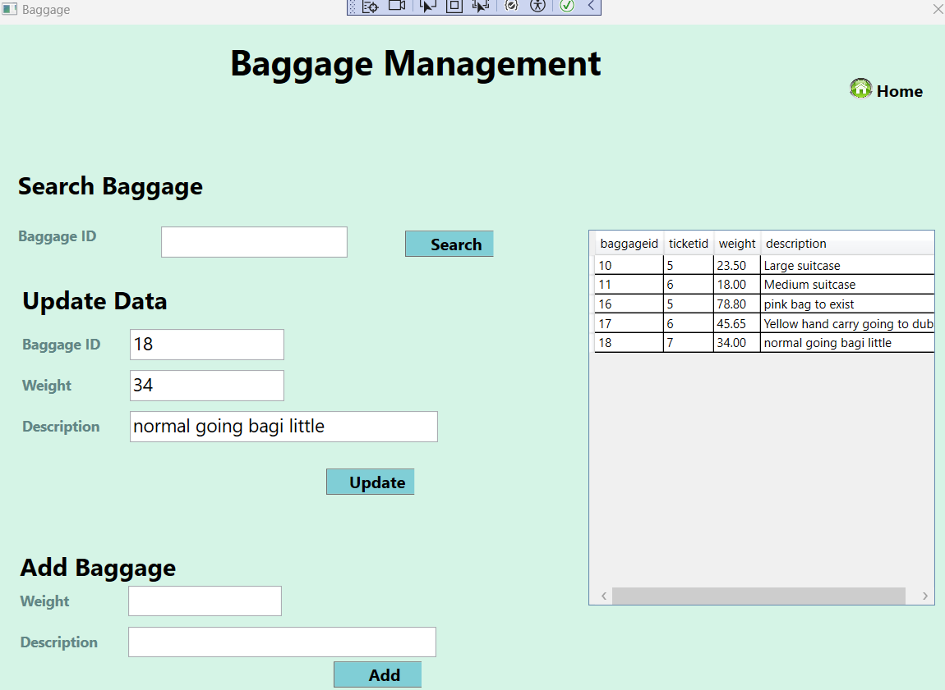
- We can update the baggae details of a specific ticket by simply adding the details.
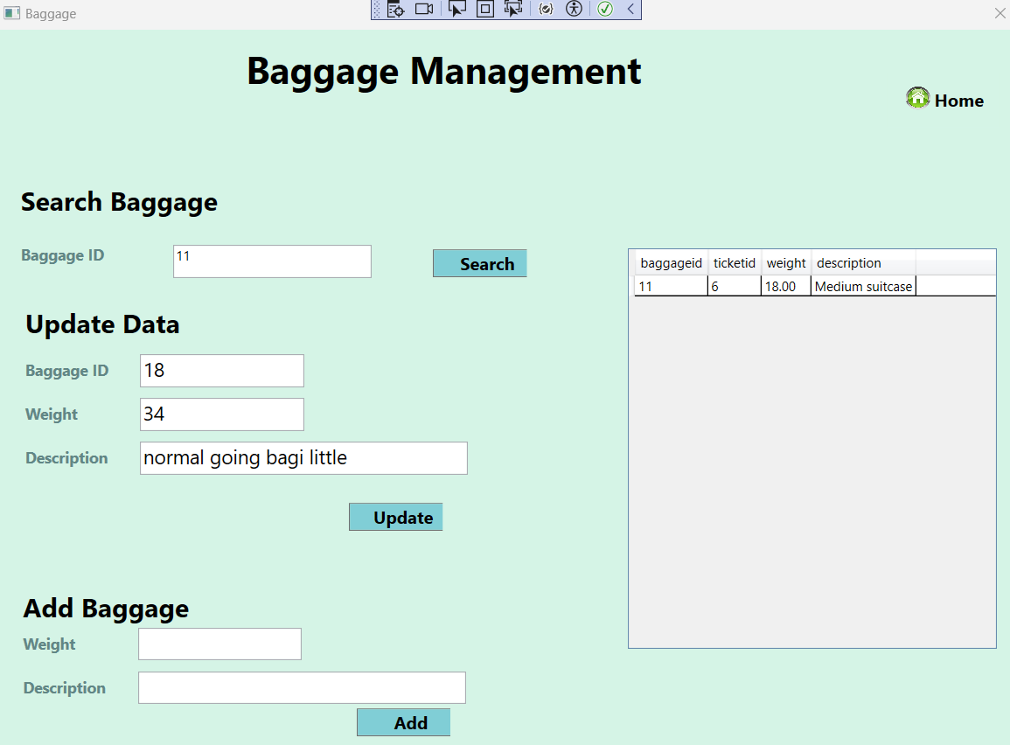
- We can search for the the specific baggage by simply entering the baggage id.

Conclusion:
In conclusion, the development of the Airport Management System (AMS) app represents a significant advancement in streamlining airport operations and enhancing overall efficiency. The intuitive interface design, comprehensive functionality, and robust testing framework ensure that the app meets the critical demands of flight scheduling, passenger check-in, baggage handling, and staff management. By addressing key operational challenges and incorporating user-friendly controls, the AMS app not only improves the accuracy and reliability of airport management tasks but also enhances the passenger experience through timely and efficient service. The extensive test cases validate the system's robustness and readiness for deployment in real-world environments, ensuring that it can handle the complexities and scale of modern airport operations effectively. With its innovative features and rigorous quality assurance, the AMS app is poised to become an indispensable tool for airports, contributing to smoother, safer, and more efficient air travel.

REFERENCES

- Allen, J. (2020) Pro WPF in C# 2010: Windows Presentation Foundation in .NET 4. 1st ed. New York: Apress.
- Barker, R. and Loney, K. (2010) Oracle PL/SQL Programming. 5th ed. Sebastopol, CA: O'Reilly Media.
- Ben-Gan, I., Itzik, R. and Machanic, A. (2015) T-SQL Fundamentals. 3rd ed. New York: Microsoft Press.
- Bowes, B. (2016) Windows Presentation Foundation 4.5 Cookbook. 2nd ed. Birmingham: Packt Publishing.
- Casteel, J. (2017) Oracle 12c: SQL. 2nd ed. Boston: Cengage Learning.
- Chappell, D. (2009) Introducing Windows Presentation Foundation. 1st ed. Redmond, WA: Microsoft Press.
- Dean, R. (2018) SQL Server 2017 Administration Inside Out. 1st ed. New York: Microsoft Press.
- Gajendar, A. (2019) Mastering WPF: Data Binding with XAML. 1st ed. New York: Apress.
- Kothari, A. (2020) SQL Server Performance Tuning. 1st ed. Birmingham: Packt Publishing.
- MacDonald, M. (2010) Pro WPF in C# 2010: Windows Presentation Foundation in .NET 4. 1st ed. New York: Apress.
- Millman, G. and Sabin, M. (2018) Beginning WPF 4.5 by Full Example. 1st ed. New York: Apress.
- Moroney, L. (2016) Expert C# 5.0: with the .NET 4.5 Framework. 1st ed. New York: Apress.
- Papadopoulos, K. and Voulgaris, A. (2018) Mastering SQL Server 2017. 1st ed. Birmingham: Packt Publishing.
- Petkovic, D. and Moldovan, D. (2020) Programming with Microsoft Visual Basic 2019/2020. 1st ed. New York: Cengage Learning.
- Troelsen, A. and Japikse, P. (2017) Pro C# 7: With .NET and .NET Core. 1st ed. New York: Apress.

APPENDIX

